**NAME : AWANTIKA KHATRI**

**STUDENT ID : BIT-24S-015**

**DEPARTMENT : INFORMATION TECHNOLOGY**

**SUBJECT : ARTIFICIAL TECHNOLOGY**

**LAB:5**

**TASK:1**

**BASIC TASK(Alternative version)**

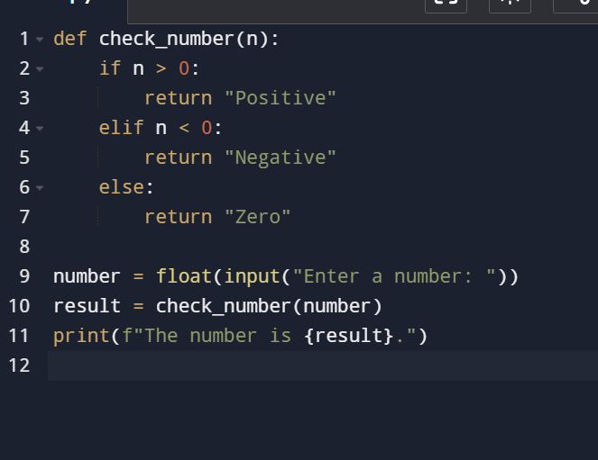

**output**

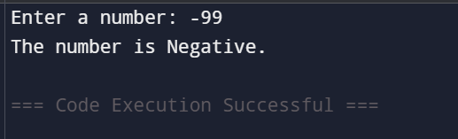

**TASK:2**

**INTERMEDIATE (Alternative version)**

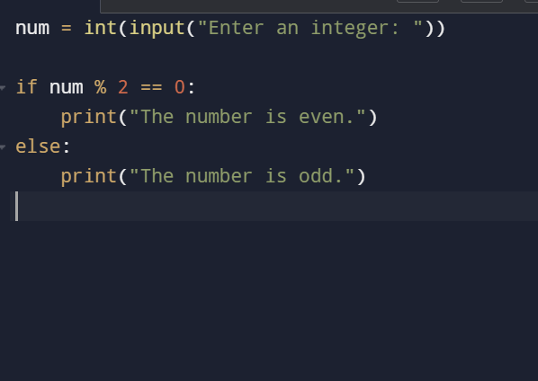

**OUTPUT**

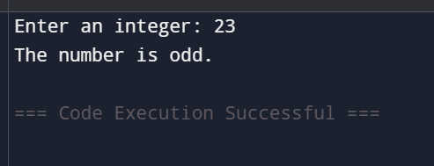

**TASK:3**

**ADVANCED (Classify student performance based on marks)**

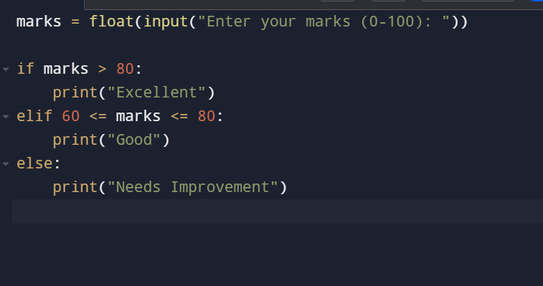

**output**

